Use-Case Realization Report (Analysis)
Print Cylinder Information

Issue <1.0>
Revision History
Date | Issue | Description | Author
<29/apr/11> | <1.0> | Initial Document | Koh Ming Jin

Table of Contents
1. Brief Description 4
2. Flow of Events 4
2.1 Standard Flow 4
2.2 Exception 4
3. Interaction Diagrams 4
3.1 Collaboration Diagram for Print Cylinder Information 4
4. Participating Objects 4
4.1 Print Cylinder Information Page 4
4.2 Cylinder Controller 4
4.3 Cylinder 4
5. Class Diagrams 5
5.1 Domain Class Diagram: Print Cylinder Information 5
6. Derived Requirements 5

Use-Case Realization Report
Print Cylinder Information

Brief Description
This use case enables an operation manager to print a cylinder information record.

Flow of Events
The standard flow of events for this use case and any exceptions are described in the following subsections. See section 3.1 for an overview of the participating Actors and Domain Objects.

Standard Flow
The flow of events is described as follows:

- The use case starts when Operation Manager views a list of cylinder information and selects the Print Cylinder Information option of the system.
- The Print Cylinder Information Page will display
- Once the Operation Manager has verified all information and click on print option, the printer will start to print the cylinder information.
- The use case terminates.

Exception
- Unable to detect the printer. The user will be alerted if the computer is unable to detect the printer.

Interaction Diagrams

Collaboration Diagram for Print Cylinder Information
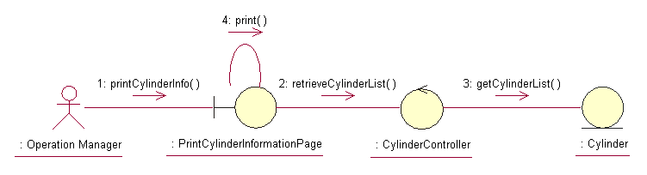

Participating Objects

Print Cylinder Information Page
This object renders the contents to allow authorized actors to perform the print cylinder priority request. The Director, Department Manager and Operation Manager actors use this object.

Cylinder Controller
This object acts as the middleman between “Print Cylinder Information” Page and the Cylinder object. It will translate interactions with the view into actions to be performed by the Cylinder object.

Cylinder
This object stores the details concerning the cylinder information of the COMS.

Class Diagrams

Domain Class Diagram: Print Cylinder Information
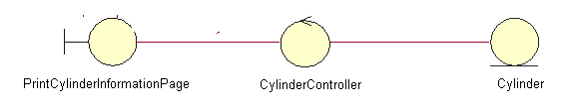

Derived Requirements
The Operation Manager PC keyboard and mouse will be used to enter Cylinder Information details (if any) and view all the system responses.

